AQUA 2012: Science responds to industry needs
As with all the events organised by the European and World Aquaculture Societies, our AQUA 2012 event in Prague in September will focus on how science plays a fundamental role in the development of the global aquaculture industry.
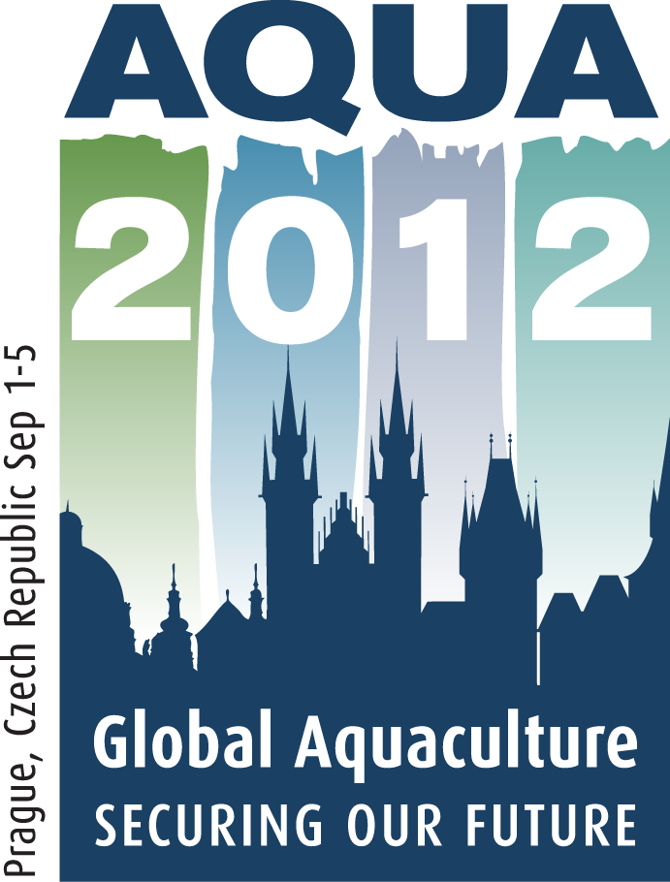
The AQUA 2012 theme, Global Aquaculture: Securing Our Future, has obvious implications in global and regional food security and aquaculture trade, placing aquaculture products in the global fisheries market. It also refers to economic and environmental sustainability and the image of aquaculture activities.
As the latest AQUA 2012 advertisement depicts, the event will be a truly global one, including technical sessions that cover farmed fish, shellfish, algal and crustacean species from all climatic zones and all continents.
Exhibitors from around the world will therefore be present in the AQUA 2012 trade exhibition to display their latest products and services to the sector and several special events are being organised to facilitate communication between stakeholders – and especially between science and industry – through the Farmers’ Days and through other special and additional events, such as those described below.

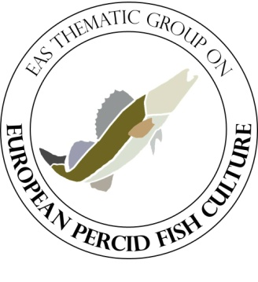
European Percid Fish Culture Workshop
The EAS thematic group on the culture of pike-perch, perch and other species of the family percidae for human consumption, stocking and conservation (European Percid Fish Culture – EPFC) will organise a workshop on September 1st, during the set-up and registration day of the AQUA 2012.
The tentative workshop schedule features a keynote presentation (to be announced) and three thematic sessions on broodstock management and fingerling production; on-growing and nutrition and marketing and training. In each thematic session, a selection of short presentations from industry and research representatives will give an overview of the current status and will pave the floor for a panel discussion.
The workshop will:
- establish a network of farmers and companies involved in percid fish production and related industries (processing, marketing, and others), scientists conducting research on percid species (applied and fundamental), and policy representatives and NGOs with a defined interest in percid aquaculture,
- highlight the latest findings from percid aquaculture research,
- give farmers and companies the opportunity to steer research by pointing out deficits in current knowledge and to kick off a dialogue between stakeholders,
- identify the need for future training and education programs for percid aquaculture practitioners,
- provide an easily accessible forum for the exchange of knowledge, ideas, materials, contacts, and much more, driven by the participants’ needs and interests, and
- send a strong signal to policy makers and research funders, underlining the fact that there is an economical future in European percid culture, so there is need for research and development to generate innovation and investment in the sector.
The workshop outcomes will be published in the EAS “Aquaculture Europe” magazine.
Aquaculture Technology and Markets Farmers’ Day
The first of the AQUA 2012 Farmers’ Days will take place on Sunday, September 2nd and will focus on technology developments and market strategies. After general introductions on each of these broad topics, specific species presentations and discussions will focus on marine fish, molluscs, shrimp and tilapia.
AQUA 2012 Sponsors Aquaculture-Industry Forum

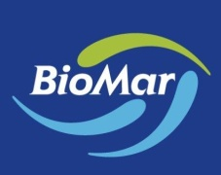

The AQUA 2012 Gold Sponsor, Biomar, the EAS Premium Sponsor MSD Animal Health and the WAS Premium Sponsor, Novus will lead a short aquaculture-industry forum that will follow the Farmers’ Day, allowing them to give their inputs on the global market within the scope of the AQUA 2012 theme. This short forum will end with a special celebration, marking the 50th anniversary of Biomar.

Freshwater Fish Farmers’ Day
Organised in partnership with the Czech Fish Farmers’ Association, the Freshwater Farmers Day will provide a forum for presentation and discussion, focussing on the following topics:
- Broodstock management and reproduction
- New species within inland aquaculture
- New culture approach providing high quality fish product
- Pond carp production
- Sturgeon culture and biology
- Percid fish culture
AQUA 2012 Farm Tours
Immediately following AQUA 2012, two special one-day farm tours will allow delegates to visit farming activities in the Czech Republic.
The first tour will focus on Pond Aquaculture, including visits to the biggest fish farm in the Czech Republic (Fishery Trebon), with its traditional fish pond (“Svet”) of 201 hectares and small processing plant. A tasting of traditional fish stew will also be on the menu. From there, the tour will continue to Nove Hrady (visiting a typical regional carp fishery with a modern hatchery and harvesting in production pond, before moving on to Vodnany and visiting the faculty – research facilities, hatchery and experimental pond area of the University of South Bohemia - and finally returning to Prague.
The second tour will focus on trout from the perspectives of visiting a small family trout farm in Vacov, before going to the other end of the scale with a visit to the biggest trout farm in the Czech Republic in Anin and finishing with a visit to the Klatovske Fishery and its modern processing line, before returning to Prague.
Still time to book your booth!
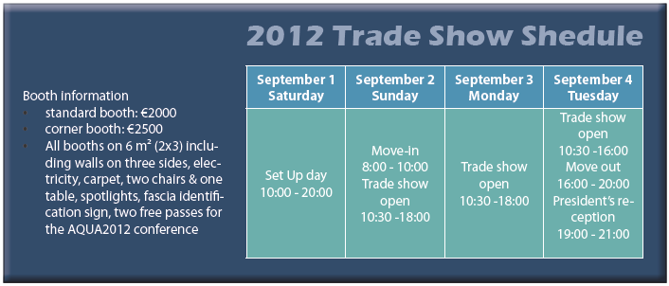
With the global interest generated by AQUA 2012, booth sales are moving quickly. However, booths are still available. See the AQUA 2012 web site at www.was.org for information on how to book your booth.

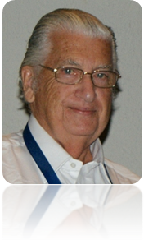
Message from the AQUA 2012 Steering Committee
AQUA 2012 Chairman Michael New and his hard-working team look forward to greeting you in Prague at what promises to be another of our great global aquaculture exhibitions and conferences. Abstracts are still being accepted for the conference and the provisional programme for the event will become available at the end of April.
We wish you good business, many important contacts – old and new - and lots of new business and scientific information. Try to find time to explore and wine and dine in Prague too - one of the spectacularly beautiful capitals of Europe!
See you all there!

For all developments on AQUA 2012,
keep checking the EAS and WAS web sites at www.easonline.org and www.was.org

